**NAME – Sadiq Mansoor**

**Excel Project Result**

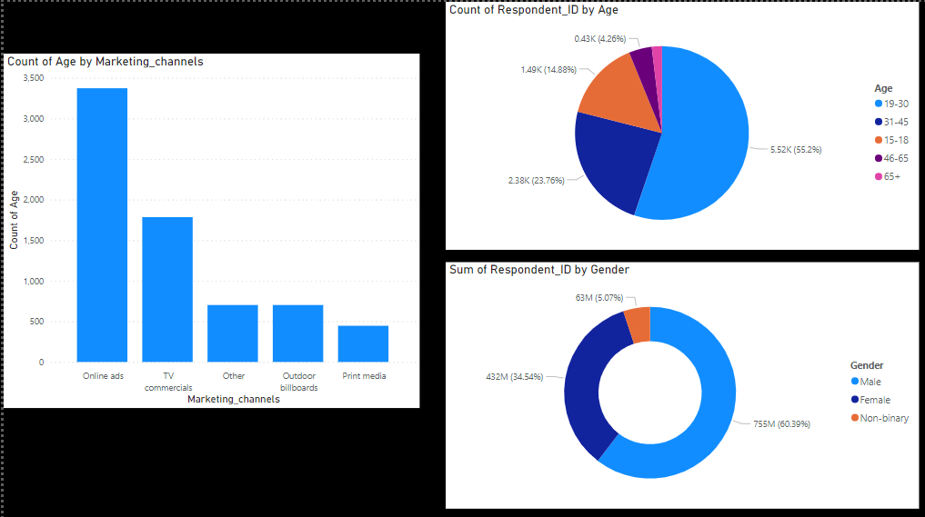

**Conclusion:**

**Gender:**

1. Men prefer energy drink more.
2. 60% of costumers are MALE.
3. 35% are Female.
4. Non-binary are 5%

**AGE:**

1. Age group (19-30) are preferring energy drink more.
2. Majority of customer ages are 19-30.

**EFFECTIVE ADS:**

1. Online Ads are most effective nowadays.
2. Online Ads effectiveness is followed by TV coomercials.

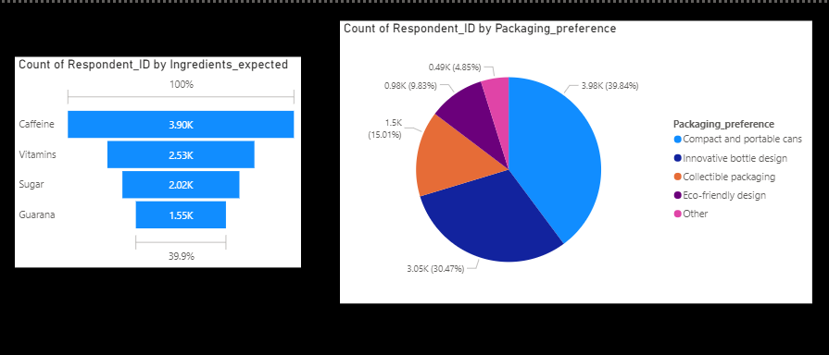

**CONSUMER PREFERENCE CONCLUSION:**

**INGREDIENTS:**

1. The preferred ingredient by most of the costumers is Caffeine.
2. Then, followed by Vitamins.

**PREFERRED PACKING:**

1. Most preferred packing is compact and portable cans.
2. 39.84% like cans packing followed by innovative bottle design.

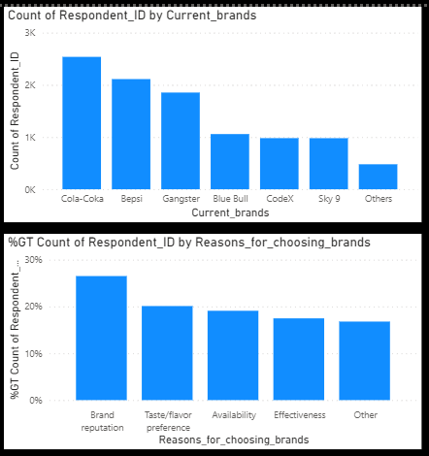

**COMPETITION CONCLUSION:**

**CURRENT MARKET LEADER:**

1. Cola-Coka is current market leader.
2. Second is bepsi.

**REASON FOR BRAND PREFERENCE:**

1. 27% of costumers prefer our brand because of Brand reputation.
2. 20% prefers it because of Taste or flavor.

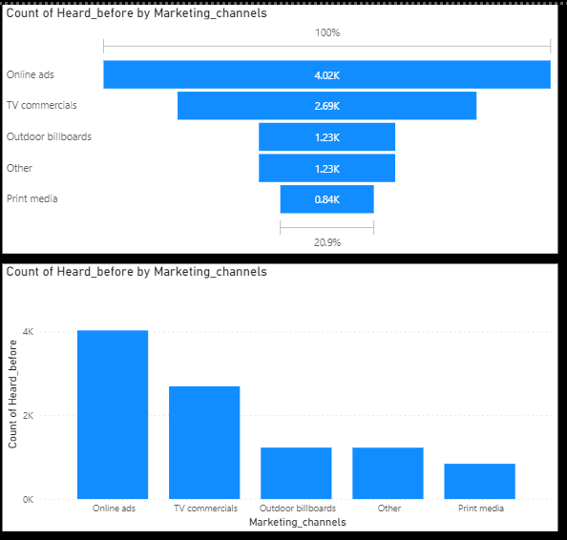

**MARKETING CHANNEL AND BRAND AWARENESS CONCLUSION:**

**Effective Marketing Channel Conclusion:**

1. Online ads can be used to reach out great number of people.
2. We can reach max customers by utilizing the modern means of marketing like online ads and TV commercials.

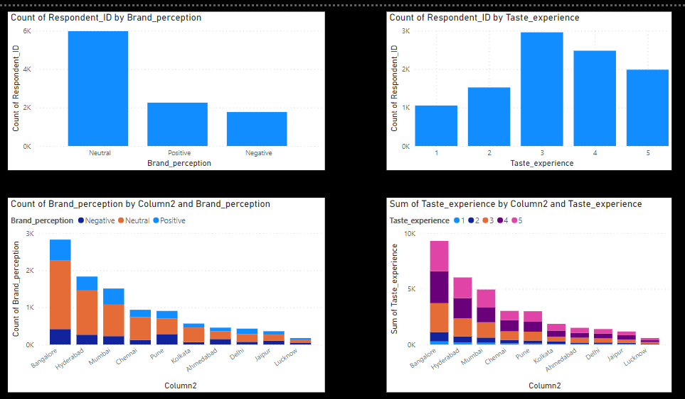

**CONCLUSION:**

1. Majority of feedback is neutral.
2. Taste experience is average.
3. Best reputation is in Bangalore then followed by Mumbai etc.
4. Taste experience positive feedback is in Bangalore then followed by Hyderabad etc.

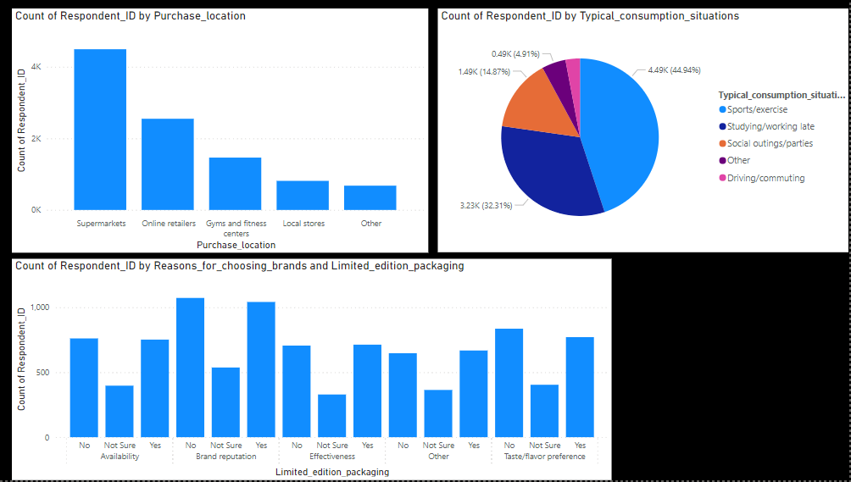

1. Super markets are preferred to buy energy drink.
2. 44.94% of costumers are using energy drink in situation of sports or exercise.
3. Limited edition packing has influenced about 39.46% of customers.

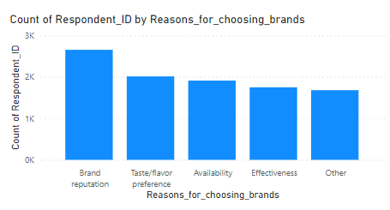

Branding should be focussed